Sully and District u3a Newsletter May 2025

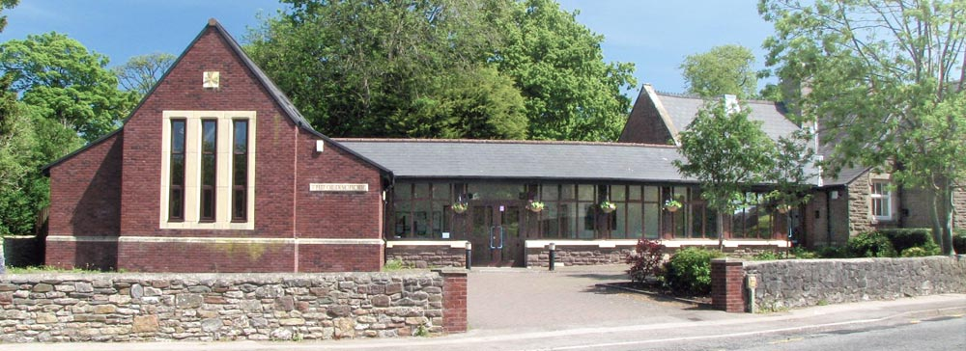

Sully U3A Trip 19th July

A Trip to Chepstow Festival of Arts on Saturday 19th July.
Join us for a day out at Chepstow during their Festival of Arts.
Stoll along the High St and view the many stalls with artists and crafters displaying their art.
Listen to buskers performing and enjoy a meal down by the riverside.
Alternatively, you could take a tour around Chepstow Castle or the museum.

Leaving Sully at 9am. arrive Chepstow at 10am
Leaving Chepstow at 4pm arrive Sully 5pm.

There will be no cost to members for this trip so please put your names down as soon as possible to secure your place on the coach.
More information and previous years photos can be found at www.chepstowfestivalarts.com
You can also find more information
at "sully.u3asite.uk" on the Events page.
There is a link to the Festival website and members can contact the Organisers from the link on the page.

Please register your interest by email to chepstowtrip@sullyu3a.co.uk

Group News

Book Club 2

Book Club 2 has released its summer reading programme:
19 June: Precipice - Robert Harris
17 July: Northanger Abbey – Jane Austen
21 August: Score – Jilly Cooper

We buy our own books and aim to follow a mix of long/short and light/serious titles.

We meet at 10.30 on the third Thursday of each month in the Jubilee Hall at the Old School Sully.
We’d love to welcome new members. Just drop us a line at bookclub2@sullyu3a.co.uk.

Concert in Llandaff Cathedral on 11 April 2025

Following a visit by Russell Bright from Barry Male Voice Choir to recruit men for a one-off choir in aid of Prostate Cymru, the concert took place on 11 April at Llandaff Cathedral and was a great success, raising over £15000 in aid of Prostate Cymru, a charity which aims to increase awareness of this underpublicized cancer.
The concert can be viewed on YouTube under the umbrella of Barry Male Voice Choir The link is as follows:
Men United in Song concert in aid of Prostate Cymru - Llandaff Cathedral
Our treasurer, John Williams, was one of two Sully u3a members who performed at the concert. He is also a member of the u3a Writing Group run by Lorraine Wilson and decided to write about his experience for their May meeting. His piece follows:
My Journey to Llandaff Cathedral
It all began on 9th January 2025, Sully u3a Enrolment Day. That is the day on which I, as treasurer, and my colleagues collect the annual subs for the coming year. This year a man called Russell Bright from Barry Male Voice Choir had been booked to sit in the foyer and try to recruit men to join Men United in Song, a temporary choir set up to raise money for Prostate Cymru, a charity which raises awareness of this common but underpublicised cancer.
Russell arrived late to the u3a meeting and, without my knowledge, a decision was made to put him on stage to talk to the members already seated. From my point of view this was interrupting the important business of collecting £10 from those who had not yet paid their annual subscription. From the point of view of several people sitting at the back of the hall, I was the annoying interruption and they shouted to me to be quiet. I felt a bit grumpy about this because people have no idea just how important enrolment day is in a treasurer’s diary.
To those who were listening to him, Russell said that BMVC (Barry Male Voice Choir) were working with Prostate Cymru to establish a temporary choir of about forty men which would meet over ten consecutive Tuesdays with the objective of performing in Llandaff Cathedral on 11th April. I was not interested, and not really listening.
When, two days later, my partner Anita said she assumed that I would be signing up, I pointed out that while I love singing it is informal sessions involving no learning and no performance that I enjoy, not the slog of learning stuff and entertaining others. She reminded me that it was something I had never done before and might not have the chance to do again. She is persuasive and I decided to give it a go.
When I turned up in Barry for the initial information session, I found that, instead of the forty men BMVC had been looking for, 110 had turned up. We each sang in one of four parts: Tenor 1, Tenor 2, Baritone and Bass. The voice test showed I was a tenor 2.
It is a truism much beloved by trainers that “failing to prepare is preparing to fail” but no-one could level that charge against BMVC. On Day One we were given details of all the songs we were going to learn and the dates we were
going to practise them. We were given sheet music for every song and a recording of someone singing our part. We paid £30 for all the materials with half covering the costs and half going to Prostate Cymru. The reason we were staging the concert was emphasised strongly with a presentation from the founder of the charity. In fact some of my fellow choristers had joined Men United in Song because they had previously benefited from Prostate Cymru’s work.
During the ten weeks of rehearsals, we learned nine songs from a variety of genres: a Proclaimers pop song called Sunshine on Leith, an operatic chorus called Divine Brahma, a sea shanty about whaling called the Wellerman song, a religious pair of songs, My Lord what a Morning and Ride the Chariot, patriotic songs Sosban Fach and O Gymru, an Irish folk song called The Fields of Athenry, and the emotional song Bring Him Home from the musical Les Miserables.
At each rehearsal I was pleasantly surprised by how many of us had done all our own personal practice before the joint choir practice. The 110 men quickly whittled ourselves down to eighty but the eighty were dedicated and enthusiastic.
When we were told that we would be performing without sheet music, I was slightly intimidated. The tune was not so bad but I found learning the words difficult, particularly the two songs in Welsh and the energetic Wellerman sea shanty which has lots of words sung quickly. My worry grew when I learned that the concert was being filmed, giving scope for close up shots of lips
moving out of sync with the script. Anyone who remembers the embarrassment of John Redwood making a hash of the Welsh National anthem will understand my fears.
We were led by an incredibly talented musical director, Dot Connell. Very small in stature, Dot is huge in every other way: musical knowledge, leadership skills, sense of humour, energy and clarity of focus. Every quality which was needed for the job in hand, she possessed in abundance. Under her guidance, the choir was sounding good but, as March came to an end and April began, there was some nervousness.
Dot was very supportive and extra voluntary rehearsals were held for those members of the choir worried about the songs themseves. But it was not the
songs which were worrying me. I was concerned about the length of the day, the lack of sufficient toilet facilities, becoming cold in Llandaff Cathedral in the prescribed uniform of black shoes, socks and trousers and a white long-sleeved shirt and tie, and finding it difficult to stand for the necessary amount of time. I decided that all I could do was hope for the best.
When 11th April finally came I was picked up by coach from the Merrie Harrier to get to the cathedral for rehearsal from 3.30 till 5. It was a beautiful sunny day. As I entered the cathedral I saw how it is dominated by Epstein’s Majestas sculpture of Jesus hanging on the concrete structure spanning the nave. The stage had been erected underneath the statue and the concrete legs looked like the proscenium arch in a theatre.
Our first job was to establish where we were to stand and practise walking on and off the stage which just about accommodated eighty men. Being below average height I was towards the front facing the audience with my feet on the stone chancel step rather than the temporary dais erected behind me. This made me feel secure. I also noticed that the sunshine meant that the cathedral was warmer than usual. When not on stage our choir was located at the eastern end of the cathedral behind the high altar and a door to the outside world was left permanently open so that we could stand outside in the warm evening air, rather than the freezing conditions I had feared.
The concert was amazing. We opened with the magisterial Divine Brahma, accompanied by the cathedral organ. The audience were blown away by its power and the choir’s obvious energy. At the end of it, I felt slightly tearful, a feeling I experienced several times more in the following two hours. My family and friends were full of praise after an evening which everyone enjoyed.
I have a great feeling of mission accomplished. Where several of my fellow choristers are intending to swell the ranks of BMVC, several more are like me, proud that we gave of our best and happy to be hanging up our spurs.

Speakers

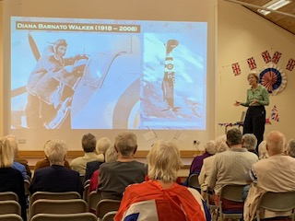

Women with Wings by Carolyn Kirby – Report by Norma Johnson
A warm welcome was given to Carolyn Kirby who gave a very interesting and informative talk on Women with Wings at the Sully u3a meeting on the 8th May 2025 using a power point presentation of photographs and text.
Carolyn explained the Air Transport Auxiliary (ATA) service was set up in 1939 and consisted of male pilots, however in 1940 women were given the opportunity to join as the men were needed to support the RAF in the war effort and fly on missions into Europe.
The (ATA) was a voluntary service that was tasked to fly aircraft across the British Isles to deliver aircraft from factories to squadrons of the RAF and Royal Navy as well as the delivery of much needed supplies. The women pilots had to adhere to certain rules such as skirts and stockings had to be worn when flying even in open cockpits and it wasn’t until later in the war in 1943 they were allowed to wear trousers. They couldn’t use radar so they had to navigate by sight alone using visual landmarks on the ground below as they flew around the country, so flying underneath the clouds was imperative. Never knowing their next assignment, each morning the pilots had to collect their ‘chits’ that had details of the type of aircraft they were flying and the geographical locations they were flying to. Returning home once they had delivered the plane could be very problematic as they often had to catch a train, which in war time Britain, was no easy feat as they were few and far between.
Carolyn who was very moved by the experiences of these women, felt it was a story that had to be told so she used all her years of research on Women pilots and events in war torn Europe, particularly the tragedy in Katyn, Poland, to write her book When We Fall. Although a fictional novel, it is based on actual experiences of female pilots and their roles in WW2.
Carolyn chose to focus on four pilots in her talk: Diana Barnato Walker MBE (1918-2008) who was a very beautiful debutante and was the daughter of a racing driver. It was Diana’s obituary in the Guardian Newspaper that inspired Carolyn to start writing which was on VE Day 2008. Monique Agazarian (Aggie) (1920-1993) fled Armenia and is the main character in When We Fall. Aggie wasn’t one of the original eight female pilots but joined in 1943.
Amy Johnson (1903- 1941) who although flying from the UK to Australia, found this type of flying very challenging. Tragically off course and out of fuel her plane crashed in the Thames Estuary as she flew from Blackpool to Oxford in thick fog. Janina Lewandowska (1908-1940) who was a polish WW2 pilot who married her gliding instructor in June 1939 as the war in Poland started in September 1939. Janina was the only female victim of the Katyn massacre.
Being the 80th Anniversary of VE Day it was poignant to reflect how many brave men and women put their lives in danger with each mission they flew and made sacrifices on a daily basis so we could all have a better future.

Next month’s speaker

Next month: June 12 Annual General Meeting 1-45pm
Speaker: Gaynor Legall on the Topic of Tiger Bay and the World at 2.00pm

VE Day Celebrations at Sully u3a Talk on Thursday 8th May 2025

Hats off to the u3a committee who got into the spirit of VE Day’s 80th Anniversary and went all out to decorate the Hall at Sully Old School. To coincide with today’s topic Women with Wings the hall was adorned with flags, bunting and balloons. Some of the committee dressed for the occasion wearing a variety of items in red, white and blue. There were newspapers from the day, photos and an example of a food ration allowance, a ration book and identity card. Thankfully no food rationing for all the attendees as we finished the meeting with a cup of tea or coffee and a jam or Bakewell tart. A great time was had by all!!

Offer from Cowbridge U3A
Cowbridge u3a History Group Trip to Berkeley Castle or Natural History Group Trip to Slimbridge, Wed June 4th 2025
We have places on the coach for this trip, so it is now being opened to other local u3as.
See details of Berkeley Castle in this link: (in word place cursor in link and use Ctrl+click to follow link)
The Castle - Berkeley Castle
We expect to leave Cowbridge Town Hall at 9.00am, to return at about 6.00pm.
The cost for Berkeley Castle is £41-00 each, to include coach fare, and entry to the Castle with a private guided tour.
It does not include catering; there is a café on site, or it is possible to take a picnic to enjoy in the lovely gardens.
While there, it will also be possible to visit Dr Jenner's House just a few minutes' walk away, but this is not included in the price. Edward Jenner was the pioneer of vaccination. Here is a link to their website: (in word place cursor in link and use Ctrl+click to follow link)
https://jennermuseum.com/
Alternatively, if anyone is more interested in wildlife, especially birds, it will be possible to pay the coach fare only, £27-00, and be dropped off and later picked up at the nearby Slimbridge Wildlife and Wetlands Centre. Entry into Slimbridge would be your own arrangement on the day. Here is a link to their website: (in word place cursor in link and use Ctrl+click to follow link)
Slimbridge Wetland Centre | River Severn Estuary | Gloucestershire | WWT
Full payment is needed immediately please, whichever your choice. You can pay by cash, cheque or bank transfer.
For full details about payment and to register your interest please contact Valerie Monaghan, of Cowbridge u3a. Thank you.
valeriemonaghan@hotmail.com
Ring 01446 626406
Text 07999585697

Security Update

As we are sure you are all aware, there are an awful lot of security threats out there, from hackers, to scammers, to identity thieves, malware and much more. In an effort to reduce the opportunity for such unwelcome attention, we have decided to stop publicising our u3a contact email addresses on our website. Instead, we will be utilising a function that is already in place. This means that we will only allow contact via the inbuilt forms on the website, which you may already have seen and used.

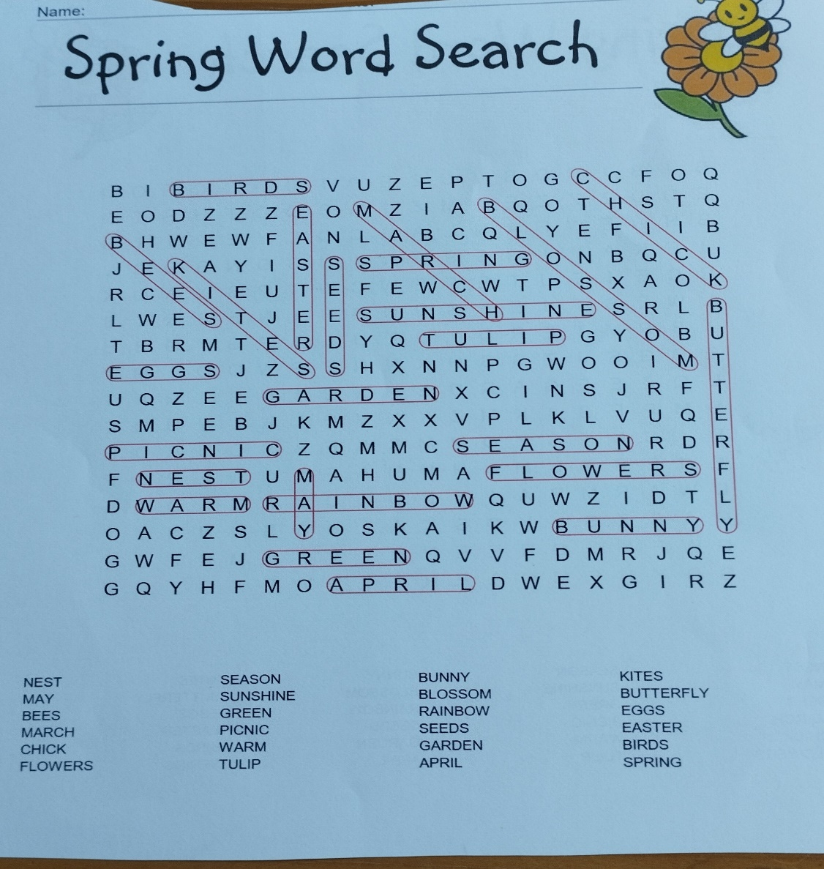
solution to last month’s word search

Regards,
Paul Lister (Sully u3a Newsletter editor)

