
Sully and District u3a Newsletter April 2025

Group News

Book Club 2
Book Club 2 are keen to encourage new members, who will be welcomed with open arms. The group generates some lively discussions on books that they choose themselves. They meet in the main hall at the Sully Community Centre at 10.30 on the third Thursday of the month.
The spring reading programme:
17 April: Demon Copperfield - Barbara Kingsolver
15 May: The Perfect Passion Company - Alexander McCall Smith
19 June: Precipice - Robert Harris
We buy our own books and aim to follow a mix of long/short and light/serious titles.
We meet at 10.30 on the third Thursday of each month at the Old School Sully.
We’d love to welcome new members. Just drop us a line at bookclub2@sullyu3a.co.uk.

Singing For Pleasure
Singing for Pleasure group is taking part in a Concert at The Paget Rooms on Saturday 3rd May at 3pm. They will be performing with choirs from Corpus Christi Catholic High School. The concert is in aid of Tenovus the Mayor’s charity.

Speakers
Example of two of the slides used during the talk on April 10th

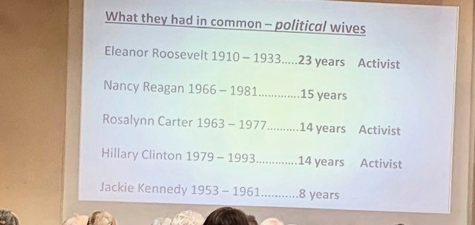

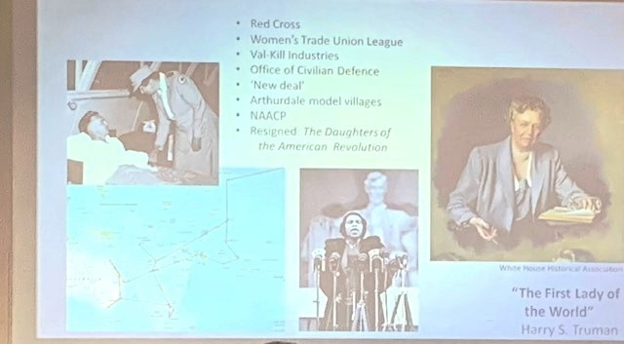

First Ladies by Geoff Henderson – Report by Norma Johnson
A welcome return to Sully u3a by Geoff Henderson who gave an informative and well received talk on the topic of First Ladies of the USA on 10th April 2025.
Using a power point presentation of information and photographs, Geoff transported us on a transatlantic journey of over 3832 miles from Wales to Washington DC. We travelled back in time and were given a brief history of the White House and some of the First Ladies who resided there for the term of their husbands’ presidencies.
The Five First ladies included in today’s talk were: Eleanor Roosevelt, Nancy Reagan, Rosalynn Carter, Jackie Kennedy and Hillary Clinton and they were chosen by Geoff for the impact they have made on future generations.
The original White House was built in 1791 but was burnt down during the War of Independence by the British. In 1829 a new White House was constructed which is the one that most of us are familiar with today. The White House is built in three main sections: The West Wing, The East Wing and the private residence of the First Family. Geoff proudly told the audience that parts of the White house roof was made of ‘terne-plate’ manufactured by a Welsh company called Gilbertsons and that this had kept the roof of the White house watertight and the First Families dry for generations!!
Geoff explained that the president and vice president are elected and have an official seal and a salary whereas the wives are unelected and unpaid but have an expected role to support their husbands’ work. The first ladies tended to be the ones that oversaw the redecoration of the White House once they took up residence. Some ladies weren’t particularly interested in interior design such as Rosalynn Carter whereas Jackie Kennedy was the opposite and was renowned for her style and elegance and even though she had extravagant taste she paid for the renovations herself. The cost of the renovation in today’s money would be 16 million - not a cheap undertaking by any stretch of the imagination!!
Many of the First Ladies undertook charity work and causes that showed their commitment to the part they played in supporting their husbands. Some were more politically involved but some less so: being a First Lady gave them the opportunity to pursue issues that were important to them. Eleanor Roosevelt was a member of the Red Cross and Hillary Clinton was appointed Head of the Health Commission and had an office in the West Wing. Rosalynn Carter was even more politically motivated than her husband Jimmy. Geoff then identified different characteristics in their spending behaviours and compared Nancy Reagan’s display of many extravagant and expensive outfits for state dinners and engagements to Rosalynn Carter who wore the same outfit to the Governor’s Ball and their Presidential Inaugural Ball. Both came under fire in the press but for different reasons. Some First Ladies were liked more than others, some were more famous than others but more importantly, they all played their part in shaping the history of America’s First Families!!

Next month’s speaker
The Speaker for next month on the 8th May is Carolyn Kirby whose book Women with Wings is about women who flew planes during the Second World War.
Next month’s speaker about women in the Second World War coincides with the 80th anniversary of V E Day and in order to commemorate this anniversary the u3a committee are planning a themed event and will be displaying a variety of interesting items, food and memorabilia in support of this. Come along and join in with the celebrations. Please bring along any photos, letters or small items relating to the war you wish to share with other u3a members. Look forward to seeing you.
--------------

Summer Days Out
Sunny days are calling us to get out and about so the Sully u3a committee are planning a number of day trips around Wales this summer. They are considering various places of interest that will appeal to as many u3a members as possible. Get your sun hats and sun cream ready as you don’t want to miss out!!
Watch this space for more information on destinations and prices.

Membership Renewals

The final membership numbers as at 31 March 2025 are as follows
Paid up members - 354
Members who have not renewed - 66. This is a good result and is fewer than at the same time last year. I have emailed (or written to those without email addresses) and informed them that their membership has lapsed and have again given details of how to renew.

Security Update

As we are sure you are all aware, there are an awful lot of security threats out there, from hackers, to scammers, to identity thieves, malware and much more. In an effort to reduce the opportunity for such unwelcome attention, we have decided to stop publicising our u3a contact email addresses on our website. Instead, we will be utilising a function that is already in place. This means that we will only allow contact via the inbuilt forms on the website, which you may already have seen and used.

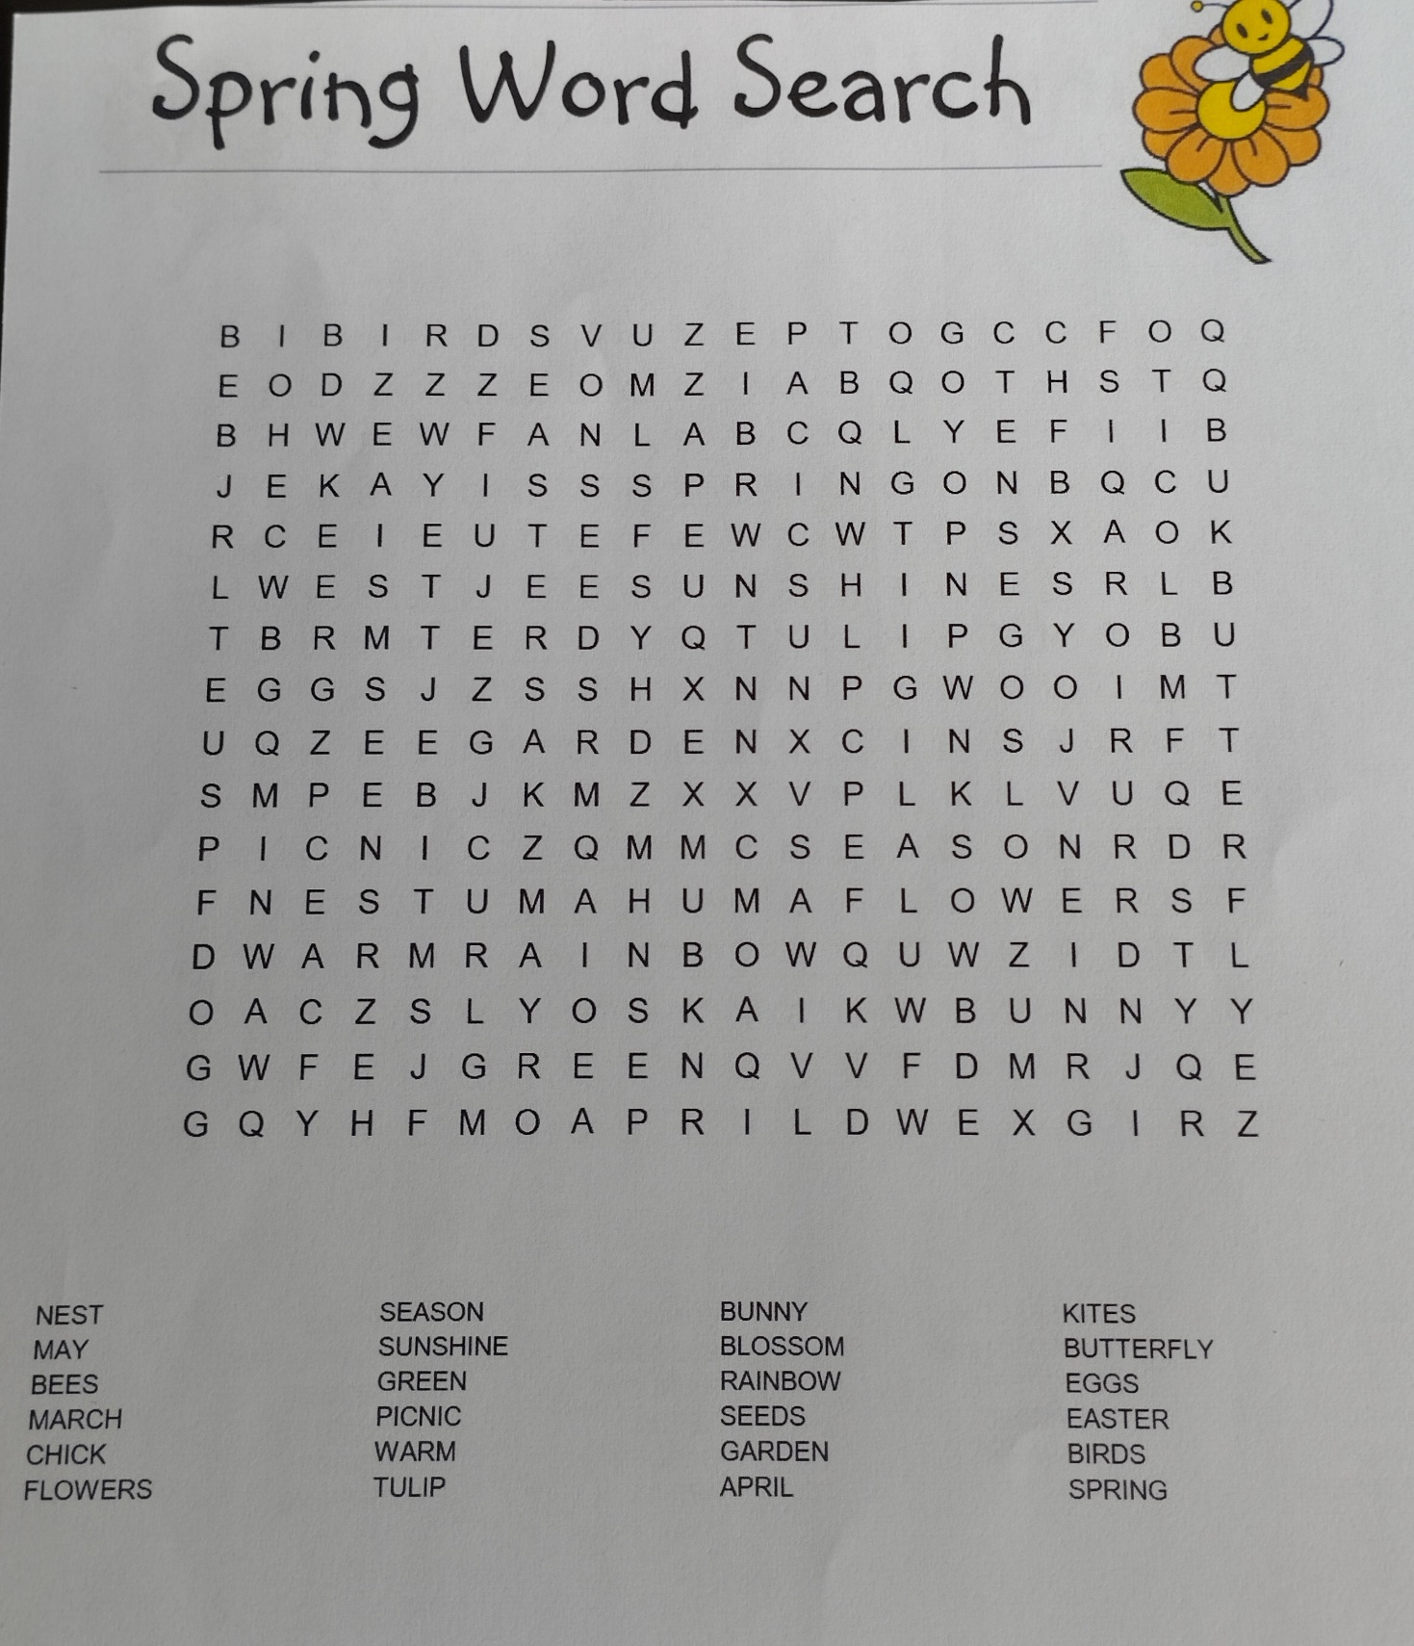
Something to pass a few minutes, print and complete
In case you cannot complete, completed grid will be included in next month’s News Letter

Regards,
Paul Lister (Sully u3a Newsletter editor)

